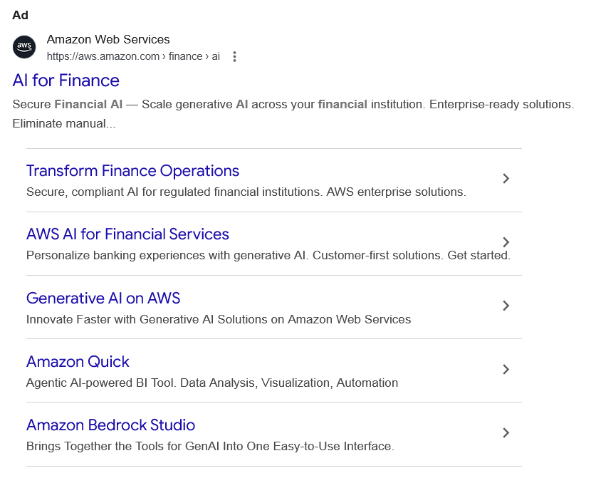
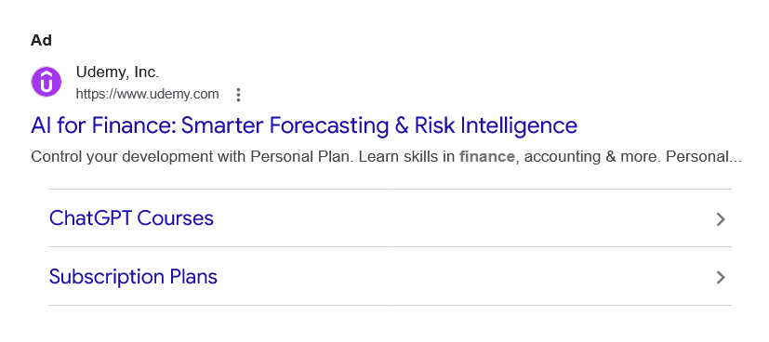
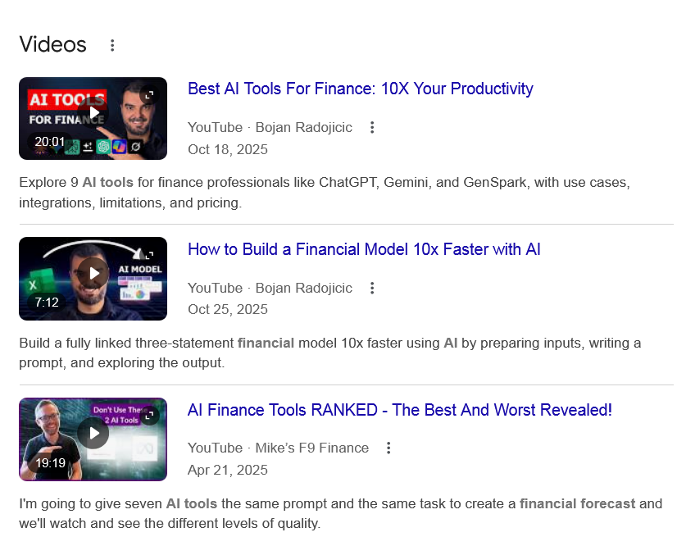
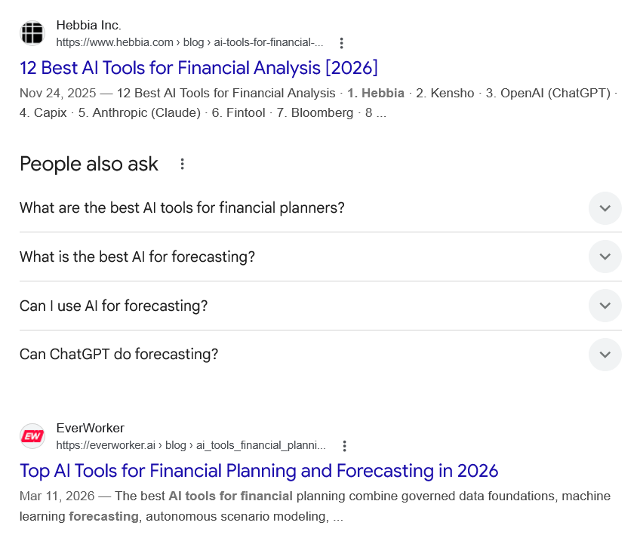
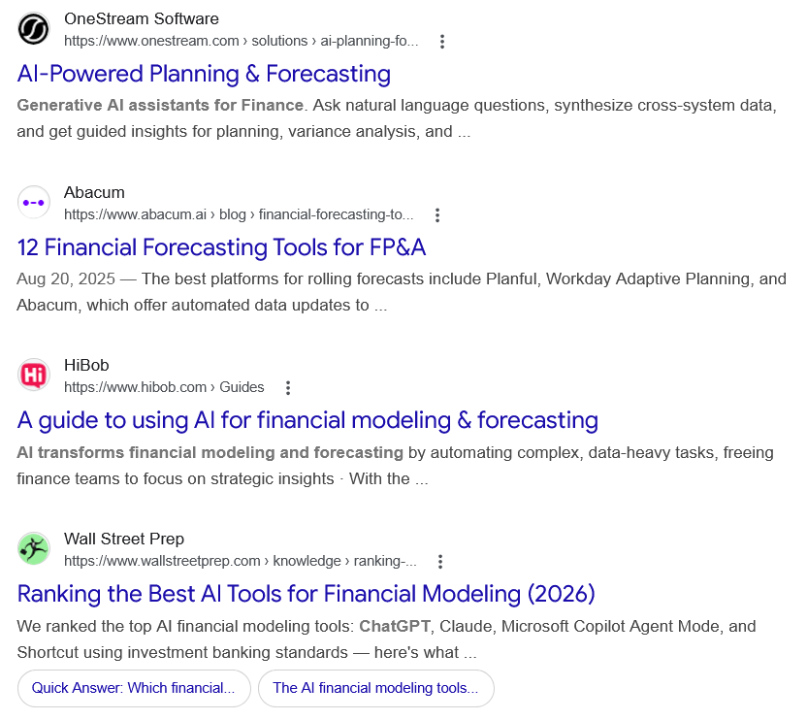
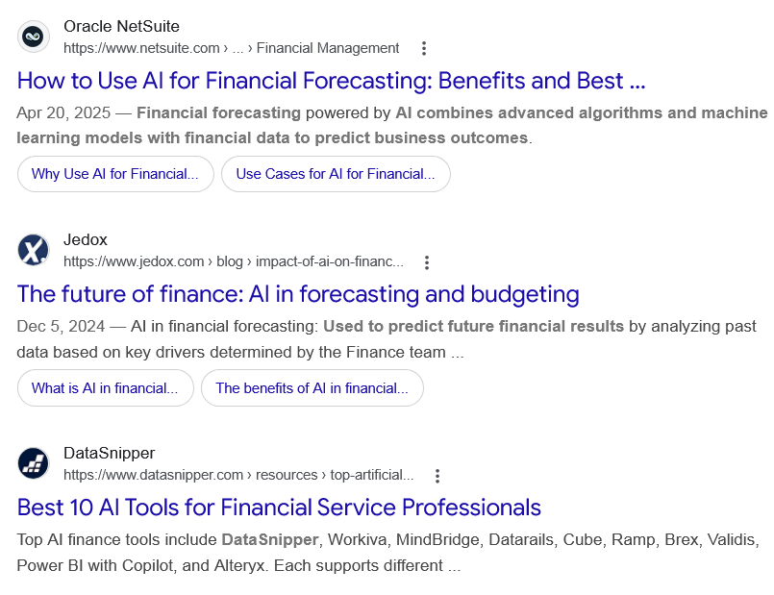
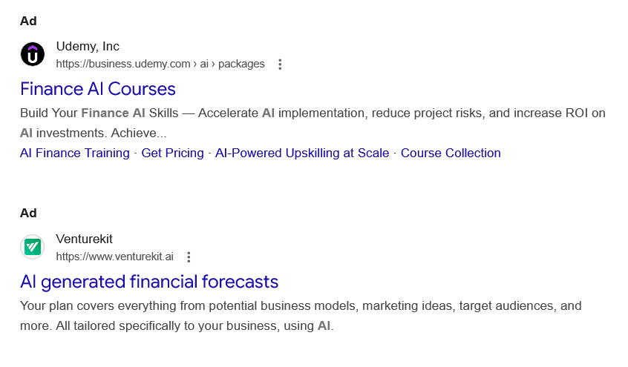
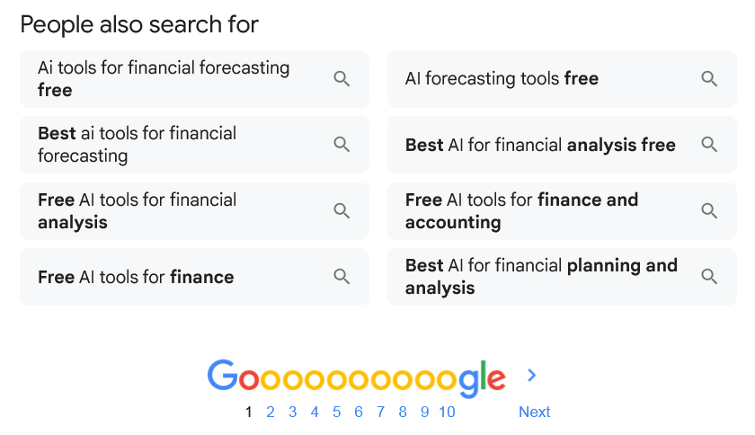
Ad

AI for Finance
Amazon Web Services
https://aws.amazon.com › finance › ai

Amazon Web Services
https://aws.amazon.com › finance › ai

My Ad Centre
Secure Financial AI — Scale generative AI across your financial institution. Enterprise-ready solutions. Eliminate manual...

Transform Finance Operations
Secure, compliant AI for regulated financial institutions. AWS enterprise solutions.

AWS AI for Financial Services
Personalize banking experiences with generative AI. Customer-first solutions. Get started.

Generative AI on AWS
Innovate Faster with Generative AI Solutions on Amazon Web Services

Amazon Quick
Agentic AI-powered BI Tool. Data Analysis, Visualization, Automation

Amazon Bedrock Studio
Brings Together the Tools for GenAI Into One Easy-to-Use Interface.

People also search for
Ad

AI for Finance: Smarter Forecasting & Risk Intelligence
Udemy, Inc.
https://www.udemy.com

Udemy, Inc.
https://www.udemy.com

My Ad Centre
Control your development with Personal Plan. Learn skills in finance, accounting & more. Personal...

ChatGPT Courses

Subscription Plans

People also search for
Videos

Best AI Tools For Finance: 10X Your Productivity
YouTube · Bojan Radojicic
Oct 18, 2025

YouTube · Bojan Radojicic
20:01
Explore 9 AI tools for finance professionals like ChatGPT, Gemini, and GenSpark, with use cases, integrations, limitations, and pricing.

How to Build a Financial Model 10x Faster with AI
YouTube · Bojan Radojicic
Oct 25, 2025

YouTube · Bojan Radojicic
7:12
Build a fully linked three-statement financial model 10x faster using AI by preparing inputs, writing a prompt, and exploring the output.

AI Finance Tools RANKED - The Best And Worst Revealed!
YouTube · Mike’s F9 Finance
Apr 21, 2025

YouTube · Mike’s F9 Finance
19:19
I'm going to give seven AI tools the same prompt and the same task to create a financial forecast and we'll watch and see the different levels of quality.

View all

Web results

12 Best AI Tools for Financial Analysis [2026]

Hebbia Inc.
https://www.hebbia.com › blog › ai-tools-for-financial-...

Hebbia Inc.
https://www.hebbia.com › blog › ai-tools-for-financial-...
Nov 24, 2025 — 12 Best AI Tools for Financial Analysis · 1. Hebbia · 2. Kensho · 3. OpenAI (ChatGPT) · 4. Capix · 5. Anthropic (Claude) · 6. Fintool · 7. Bloomberg · 8 ...
People also ask
What are the best AI tools for financial planners?
What are the best AI tools for financial services in 2025? Top AI finance tools include DataSnipper, Workiva, MindBridge, Datarails, Cube, Ramp, Brex, Validis, Power BI with Copilot, and Alteryx. Each supports different needs - from automation and anomaly detection to spend management and ESG reporting.

10+ Best AI Tools for Financial Service - DataSnipper

DataSnipper
https://www.datasnipper.com › resources › top-artificial...

DataSnipper
https://www.datasnipper.com › resources › top-artificial...
What is the best AI for forecasting?
Best AI Forecasting Tools Shortlist
- Anaplan — Best for scenario planning.
- Cube — Best for financial planning.
- IBM Planning Analytics — Best for integration capabilities.
- Jedox — Best for budgeting.
- Forecast App — Best for team collaboration.
- Dart — Best for data analytics.
- Wrike — Best for project tracking.
More items...
•
Jan 1, 2026

11 Best AI Forecasting Tools Reviewed in 2026

The Digital Project Manager
https://thedigitalprojectmanager.com › tools › best-ai-pro...

The Digital Project Manager
https://thedigitalprojectmanager.com › tools › best-ai-pro...
Can I use AI for forecasting?
By applying AI-based predictive analytics to historical and trend data, finance organizations can identify correlations and causalities to inform forecasts of future market conditions. Such AI-based forecasts recalibrate based on new data, improving their accuracy.Dec 18, 2025

AI in Demand Forecasting: Overview, Use Cases, & Benefits - Oracle

Oracle
https://www.oracle.com › scm › ai-demand-forecasting

Oracle
https://www.oracle.com › scm › ai-demand-forecasting
Can ChatGPT do forecasting?
The short answer is: yes, ChatGPT can handle the basics. But the real value of forecasting isn't the formulas. It's in the judgment, assumptions, and interpretations you make along the way. And that's where a financial professional makes all the difference.Oct 14, 2025

Can ChatGPT Build a Financial Forecast in 2025?

Indinero
https://www.indinero.com › blog › can-chatgpt-build-a-f...

Indinero
https://www.indinero.com › blog › can-chatgpt-build-a-f...

Web results

Top AI Tools for Financial Planning and Forecasting in 2026

EverWorker
https://everworker.ai › blog › ai_tools_financial_planni...

EverWorker
https://everworker.ai › blog › ai_tools_financial_planni...
Mar 11, 2026 — The best AI tools for financial planning combine governed data foundations, machine learning forecasting, autonomous scenario modeling, ...

AI-Powered Planning & Forecasting

OneStream Software
https://www.onestream.com › solutions › ai-planning-fo...

OneStream Software
https://www.onestream.com › solutions › ai-planning-fo...
Generative AI assistants for Finance. Ask natural language questions, synthesize cross-system data, and get guided insights for planning, variance analysis, and ...

12 Financial Forecasting Tools for FP&A

Abacum
https://www.abacum.ai › blog › financial-forecasting-to...

Abacum
https://www.abacum.ai › blog › financial-forecasting-to...
Aug 20, 2025 — The best platforms for rolling forecasts include Planful, Workday Adaptive Planning, and Abacum, which offer automated data updates to ...

A guide to using AI for financial modeling & forecasting

HiBob
https://www.hibob.com › Guides

HiBob
https://www.hibob.com › Guides
AI transforms financial modeling and forecasting by automating complex, data-heavy tasks, freeing finance teams to focus on strategic insights · With the ...

Ranking the Best AI Tools for Financial Modeling (2026)

Wall Street Prep
https://www.wallstreetprep.com › knowledge › ranking-...

Wall Street Prep
https://www.wallstreetprep.com › knowledge › ranking-...
We ranked the top AI financial modeling tools: ChatGPT, Claude, Microsoft Copilot Agent Mode, and Shortcut using investment banking standards — here's what ...
•
Quick Answer: Which financial...

•
The AI financial modeling tools...

How to Use AI for Financial Forecasting: Benefits and Best ...

Oracle NetSuite
https://www.netsuite.com › ... › Financial Management

Oracle NetSuite
https://www.netsuite.com › ... › Financial Management
Apr 20, 2025 — Financial forecasting powered by AI combines advanced algorithms and machine learning models with financial data to predict business outcomes.
•
Why Use AI for Financial...

•
Use Cases for AI for Financial...

The future of finance: AI in forecasting and budgeting

Jedox
https://www.jedox.com › blog › impact-of-ai-on-financ...

Jedox
https://www.jedox.com › blog › impact-of-ai-on-financ...
Dec 5, 2024 — AI in financial forecasting: Used to predict future financial results by analyzing past data based on key drivers determined by the Finance team ...
•
What is AI in financial...

•
The benefits of AI in financial...

Best 10 AI Tools for Financial Service Professionals

DataSnipper
https://www.datasnipper.com › resources › top-artificial...

DataSnipper
https://www.datasnipper.com › resources › top-artificial...
Top AI finance tools include DataSnipper, Workiva, MindBridge, Datarails, Cube, Ramp, Brex, Validis, Power BI with Copilot, and Alteryx. Each supports different ...
Ad

Finance AI Courses

Udemy, Inc
https://business.udemy.com › ai › packages

Udemy, Inc
https://business.udemy.com › ai › packages

My Ad Centre
Build Your Finance AI Skills — Accelerate AI implementation, reduce project risks, and increase ROI on AI investments. Achieve...
‎AI Finance Training · ‎Get Pricing · ‎AI-Powered Upskilling at Scale · ‎Course Collection
Ad

AI generated financial forecasts

Venturekit
https://www.venturekit.ai

Venturekit
https://www.venturekit.ai

My Ad Centre
Your plan covers everything from potential business models, marketing ideas, target audiences, and more. All tailored specifically to your business, using AI.
People also search for

Ai tools for financial forecasting free

Best ai tools for financial forecasting

Free AI tools for financial analysis

Free AI tools for finance

AI forecasting tools free

Best AI for financial analysis free

Free AI tools for finance and accounting

Best AI for financial planning and analysis

Page navigation
 | 1 | 2 | 3 | 4 | 5 | 6 | 7 | 8 | 9 | 10 | Next

